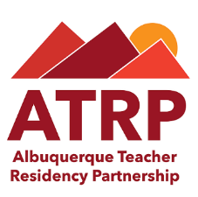
Albuquerque Teacher Residency Partnership
Resident Application Process Overview

Step 1: Submit the following through the ATRP website (abqteach.org):
- Unofficial transcripts
- Resume highlighting experience working with children and youth and/or diverse communities
- Letter of interest explaining why you are interested in becoming a teacher and why the residency program would be a good fit for you. The letter of interest should be double-spaced and no more than 500 words.
Step 2: UNM and APS will prescreen for eligibility, and eligible candidates will be invited to attend an interview day.
Step 3: Attend interview day
Step 4: Select Resident Candidates will be offered acceptance into the ATRP contingent upon passing the required tests and gaining admission to UNM.
Step 5: Resident Candidates will complete the following steps:
- Submit fingerprints
- Background check
- Take first three tests required for admission to UNM
Step 6: Resident Candidates will apply to UNM for admission.
Step 7: Teacher Residents will begin their UNM course of study on June 4, 2018.

